Ex.no:5a | DATA VISUALIZATION USING MATPLOTLIB
Date:

Aim:
To visualize sales dataset features and distributions using line charts, bar charts, pie charts, histograms, scatter plots, and box plots using Matplotlib.
Algorithm:
ALGORITHM 1: LINE CHART
Objective: To visualize total revenue across orders.
Steps
- Load the sales dataset.
- Select Order ID and Total Revenue columns.
- Plot revenue using a line chart.
- Add title and axis labels.
- Display the graph.
Interpretation
The line chart shows how total revenue varies across different orders.
# Program 1: Line Chart
plt.figure(figsize=(10,5))
plt.plot(df["order_id"].head(20), df["total_revenue"].head(20),marker="o")
plt.title("Revenue by Order")
plt.xlabel("Order ID")
plt.ylabel("Total Revenue")
plt.grid(True)
plt.show()
ALGORITHM 2: BAR CHART
Objective: To compare total revenue across product categories.
Steps
- Group the data by product category.
- Calculate total revenue for each category.
- Create a bar chart.
- Add title and axis labels.
- Display the chart.
Interpretation
The bar chart compares the total revenue generated by different product categories.
# Program 2: Bar Chart
category_sales = df.groupby(
"product_category"
)["total_revenue"].sum()
plt.figure(figsize=(8,5))
plt.bar(
category_sales.index,
category_sales.values
)
plt.title("Total Revenue by Category")
plt.xlabel("Product Category")
plt.ylabel("Total Revenue")
plt.xticks(rotation=45)
plt.show()
ALGORITHM 3: PIE CHART
Objective: To visualize the distribution of payment methods.
Steps
- Select the Payment Method column.
- Count each payment method.
- Create a pie chart.
- Display percentage labels.
- Display the chart.
Interpretation
The pie chart shows the percentage distribution of different payment methods used by customers.
# Program 3: Pie Chart
payment_count = df[ "payment_method"].value_counts()
plt.figure(figsize=(7,7))
plt.pie(
payment_count.values,
labels=payment_count.index,
autopct="%1.1f%%"
)
plt.title("Payment Method Distribution")
plt.show()
ALGORITHM 4: HISTOGRAM
Objective: To visualize the distribution of product prices.
Steps
- Select the Price column.
- Divide prices into bins.
- Create a histogram.
- Add title and axis labels.
- Display the histogram.
Interpretation
he histogram shows the frequency distribution of product prices
# Program 4: Histogram
plt.figure(figsize=(8,5))
plt.hist(df["price"],bins=10)
plt.title("Price Distribution")
plt.xlabel("Price")
plt.ylabel("Frequency")
plt.show()
ALGORITHM 5: SCATTER PLOT
Objective: To visualize the relationship between price and rating.
Steps
- Select Price as the X-axis variable.
- Select Rating as the Y-axis variable.
- Create a scatter plot.
- Add title and axis labels.
- Display the graph.
Interpretation
The scatter plot shows the relationship between product price and customer rating.
# Program 5: Scatter Plot
plt.figure(figsize=(8,5))
plt.scatter(df["price"],df["rating"],s=10,alpha=0.5)
plt.title("Price vs Rating")
plt.xlabel("Price")
plt.ylabel("Rating")
plt.show()

ALGORITHM 6: BOX PLOT
Objective: To identify outliers in total revenue.
Steps
- Select the Total Revenue column.
- Create a box plot.
- Add a suitable title and axis label.
- Display the plot.
Interpretation
The box plot shows the distribution of total revenue and helps identify possible outliers.
# Program 6: Box Plot
plt.figure(figsize=(8,5))
plt.boxplot(df["total_revenue"])
plt.title("Outlier Detection in Total Revenue")
plt.ylabel("Total Revenue")
plt.show()

Output:

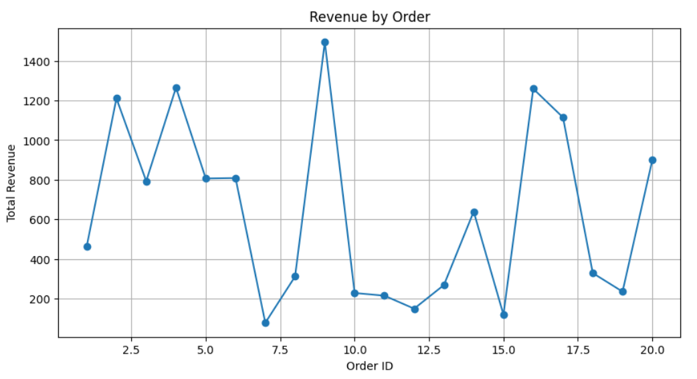

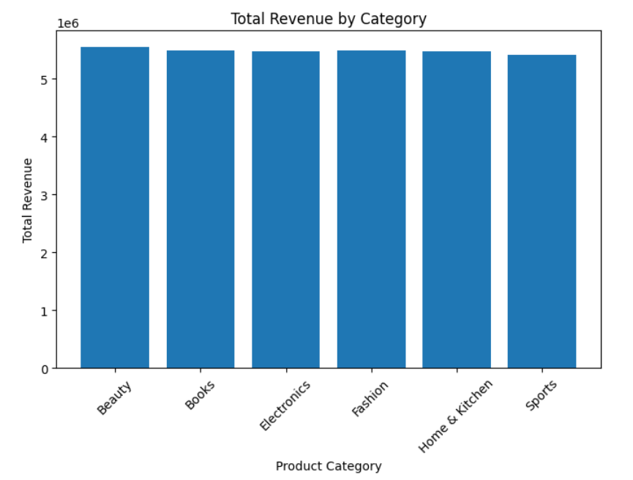

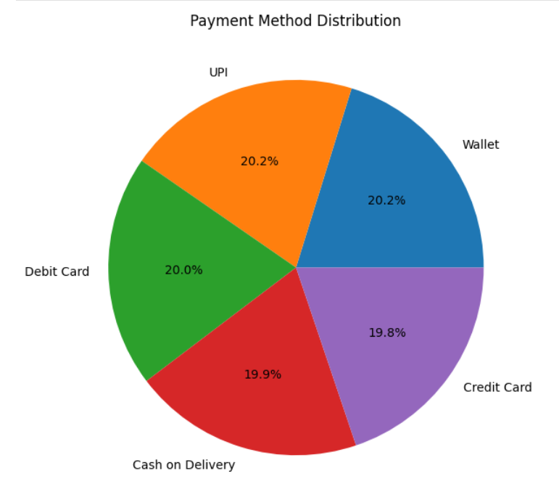

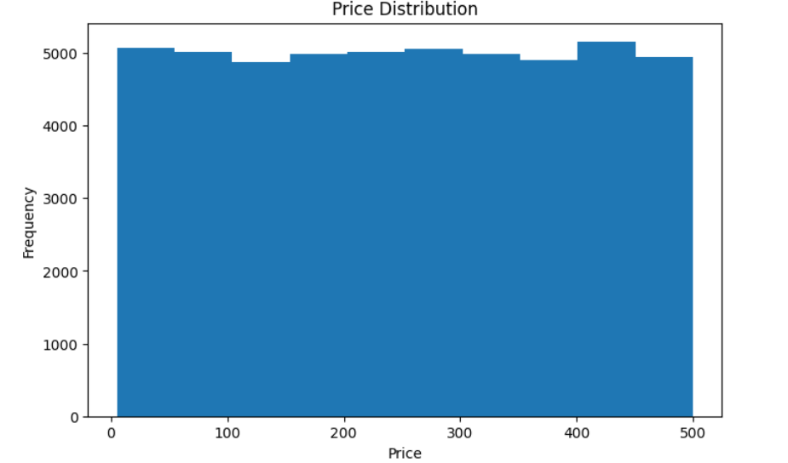

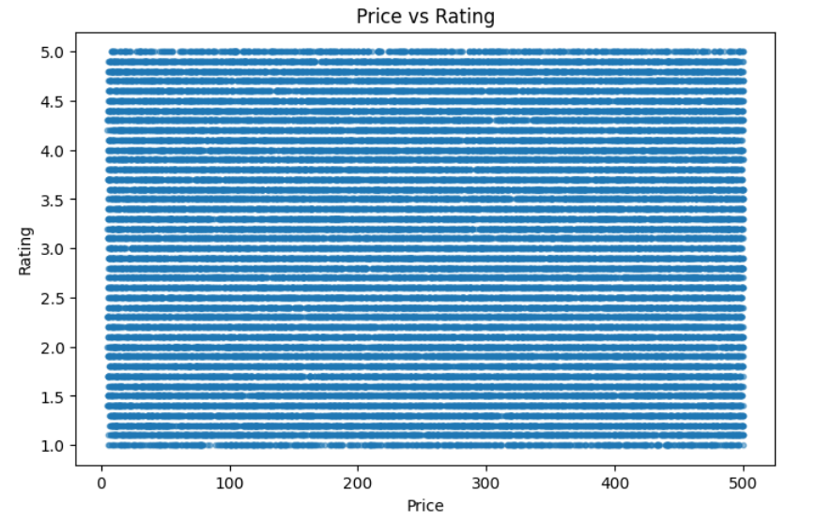

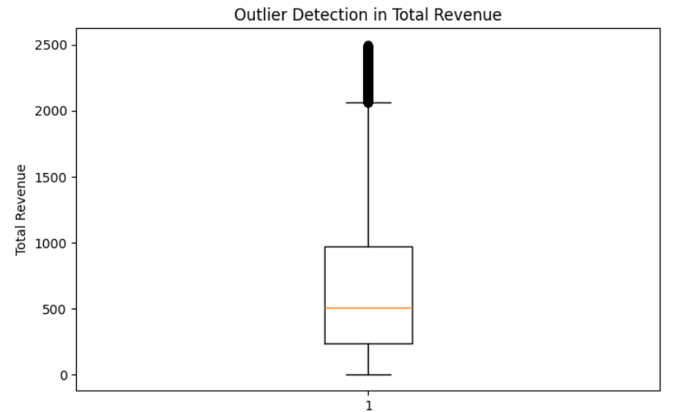

Result:

